The Worldtext Audit Engine: A Translational R&D Framework for Language-to-World Pipelines

The Operationalization of Description and the Advent of Worldtext
The developmental trajectory of artificial intelligence has precipitated a fundamental epistemological inversion in the relationship between language and physical reality. Historically, natural language has served an exclusively descriptive, interpretive, or communicative function; it has acted as a secondary, retrospective account of pre-existing phenomena, objects, or physical laws. However, with the maturation of large language models (LLMs), vision-language-action (VLA) architectures, and text-to-3D generative systems, description has rapidly transitioned into an active, operational mechanism. Prompts, captions, institutional labels, and interface texts no longer merely describe virtual or physical environments; they actively instantiate, mathematically constrain, and physically authorize the actionable architectures of those generated environments.¹
The resulting computational output is not merely a visual surface or a digital painting but a "worldtext"—a highly programmable media object where visual plausibility frequently conceals structural, physical, or causal invalidity. In this emerging paradigm, a text prompt effectively operates as a compiler for reality. The user inputs a description, and the generative system outputs a spatial matrix complete with physics, object relationships, and agent affordances. Yet, the current state of generative interface development overwhelmingly privileges aesthetic coherence, pixel-level fidelity, and semantic novelty over constraint visibility, failure explanation, and downstream accountability.² A generated environment may visually resemble a functional laboratory or a domestic kitchen, yet possess zero valid collision meshes, lack proper material property designations, and hallucinate physical affordances that, if acted upon by an autonomous robotic agent or a human user in Extended Reality (XR), would result in catastrophic failure.¹
This critical disparity necessitates a robust, translational research and development framework for auditing language-to-world pipelines. As generative AI transitions from producing static 2D images to generating interactive 3D environments, spatial computing domains, and synthetic training grounds for robotics, existing evaluation metrics remain fundamentally mismatched to the task. The Worldtext Audit Engine represents a proposed research and development architecture designed to intervene precisely at this juncture between language and simulated reality. It functions as an accountability layer and a systematic diagnostic toolset that extracts entities, relations, spatial assumptions, material claims, and uncertainty gaps from a textual description before that description is compiled into a simulator, an XR scene, a robotics planner, or a spatial interface. By treating generated worlds as operational contracts bound by the original linguistic description, the engine asks not whether a generated world simply looks real, but what specific physical and spatial actions its originating description has authorized, what structural guarantees the computational system has actually verified, and where physical or legal constraints may be dangerously violated.
The urgency of this R&D program is underscored by the rapid commercial repositioning toward world models and simulators.⁴ World models are predictive representations of how environments evolve under specific actions, and they have become a central, indispensable component of robot learning.⁴ They support policy learning, task planning, massive-scale data generation, and rapid evaluation. However, the literature and the tooling surrounding these models remain highly fragmented across differing architectures, functional roles, and embodied application domains.⁴ Without a unified audit layer, researchers and builders lack the necessary tools for determining precisely when a description becomes operationally binding, leading to a pervasive sim-to-real gap where the physical realities of deployment clash violently with the hallucinated physics of the training simulation. The Worldtext Audit Engine addresses this by proposing a shared taxonomy, a suite of domain-specific validators, and an inspectable provenance trail from the initial human prompt to the final machine action.

The Linguistic Foundation: Speech Acts, Procedural Rhetoric, and Operative Description
To formalize the auditing of generated environments, the linguistic inputs driving these systems must be radically reconceptualized through the lens of pragmatic linguistics. Speech act theory, originating with philosopher J.L. Austin and substantially expanded by John Searle, posits that language does not merely represent reality; it performs actions.⁵ Within this theoretical framework, speech acts are typically categorized into five distinct classes: representatives (which describe states of affairs or convey information believed to be true), directives (which attempt to compel the listener to perform or refrain from a certain action), commissives (which involve the speaker committing to a future action), expressives (which express the speaker's emotional or psychological states regarding a situation), and declaratives (which fundamentally alter reality through the utterance itself, such as declaring a legal verdict).⁶
In the context of generative world models, a text prompt is ostensibly a representative act—a user describing a scene, such as "a red chair in a well-lit room." However, operationally, it functions simultaneously as a directive act compelling a computational system to synthesize an environment, and a declarative act that establishes the foundational physical laws of that localized environment.⁵ This functional duality introduces profound complexities in parsing the true, executable intent of a generative input. Recent evaluations of Large Language Models highlight their evolving capacity to process and understand indirect speech acts, further complicating the audit landscape.⁶ These indirect acts include ReDi (a representative statement functioning as a directive, e.g., stating "it is cold in here" to command someone to close a window), ReCo (a representative functioning as a commissive), and ReEx (a representative functioning as an expressive).⁶ When a user prompts a world-generation system with an indirect directive, the system must infer unstated physical, spatial, and temporal dependencies.
If these unstated dependencies are misunderstood, hallucinated, or misaligned, the system introduces what speech act theory terms "perlocutionary effects"—the real-world impacts, consequences, or downstream physical manifestations of the speech act.⁵ In standard language models, perlocutionary effects often manifest as representational harms, such as stereotyping, demeaning outputs, or social erasure, where the generated output implicitly or explicitly fails to recognize a social group based on flawed locutionary logic.⁵ However, in language-to-world pipelines, perlocutionary effects extend far beyond representational harm into the realm of severe physical and spatial hazard. A prompt that inadvertently hallucinates an unstable architectural scale, a false doorway, or a structurally unsound bridge creates a literal perlocutionary trap for any autonomous agent, robotic platform, or human user operating within that synthetic space.
Speech Act Category (Searle) | Traditional Linguistic Definition | Operational Function in Text-to-World Generation | Potential Perlocutionary Hazard in Simulation
Representative | Describing a state of affairs believed to be true. | Providing the semantic baseline of the scene (e.g., "A modern kitchen with a marble counter"). | Visual hallucination masking missing spatial data; object rendered without functional volume.
Directive | Compelling a listener to perform an action. | Instructing the generative engine to synthesize specific assets and geometry. | Engine misinterprets indirect directives (ReDi), omitting necessary physical collision meshes.
Commissive | Committing the speaker to a future course of action. | Binding the simulation to maintain continuity and physics across time steps. | Temporal instability; objects phasing through geometry in subsequent generated frames.
Expressive | Conveying an emotional or psychological state. | Influencing the lighting, aesthetic style, and mood of the environment. | Aesthetic filters overpowering functional visibility, leading to agent navigation failure.
Declarative | Altering reality simply through the utterance itself. | Establishing the absolute rules, bounds, and physics engine parameters of the world. | Establishing false physical laws (e.g., incorrect gravity parameters) based on poetic text prompts.
Procedural rhetoric, a concept developed by Ian Bogost, further illuminates this dynamic by examining how rules and simulated processes persuade, govern, and constrain users.⁸ Bogost defines procedural rhetoric as the art of persuasion through rule-based representations and interactions rather than spoken word or standard imagery.⁸ This suggests that the computational execution of a prompt carries inherent rhetorical and physical authority; the generated world "argues" for its own reality through its interactive constraints.⁸
The Worldtext Audit Engine leverages this linguistic and rhetorical foundation to map the explicit locution (the specific words used in the prompt) to the resulting computational perlocution (the physical properties and rules generated), actively identifying deviations and false affordances. This is further complicated by the advent of full-duplex, multimodal interaction models. Frameworks like ELLSA (End-to-end Listen, Look, Speak and Act) enable AI models to simultaneously perceive and generate across vision, text, speech, and action within a single architecture.⁹ ELLSA achieves this via a Mixture of Experts (MoE) framework, allowing agents to engage in spoken dialogue while simultaneously executing complex manipulation actions, instantly stopping an action upon hearing a verbal interruption or adapting behavior in real-time to conversational dynamics.⁹ In a worldtext paradigm where models are constantly listening, looking, speaking, and acting, the audit engine cannot simply validate a static initial prompt; it must continuously audit the ongoing stream of speech acts that dynamically reshape the agent's environment and operational constraints.⁹

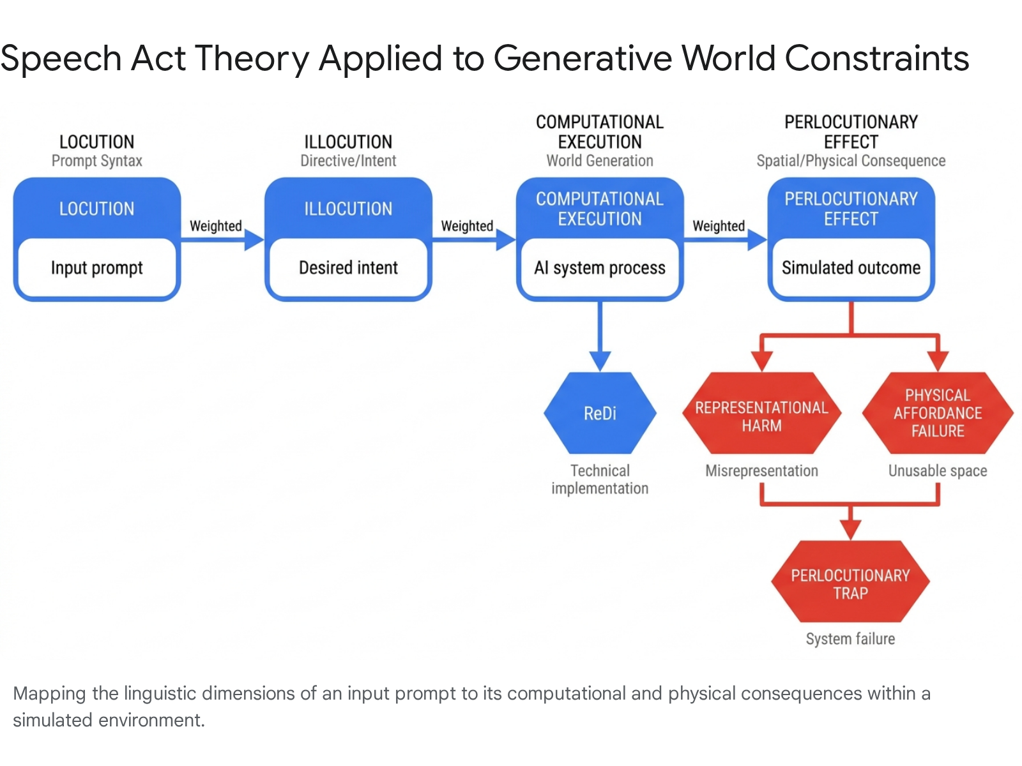

The Generative Bottleneck: Geometry, Semantics, and Affordances
The central technical bottleneck in auditing generated worlds lies in the persistent disparity between geometric generation and semantic affordance. Text-to-3D generative methods have achieved remarkable progress over the past several years, driven by advancements in neural 3D representations, the development of extensive datasets, and the innovative application of text-image foundational models for 3D synthesis.² However, these systems inherently prioritize surface aesthetic quality over functional integrity. Affordance segmentation, which aims to decompose 3D objects into discrete parts that serve distinct functional roles (enabling models to reason about object interactions rather than mere passive recognition), is frequently compromised when generative models rely solely on weak or ambiguous geometric cues.¹
Sparse point clouds, occlusion, and noisy reconstructions provide extremely limited functional information, leading models to produce highly unstable or coarse functional boundaries.¹ Extensive research indicates that the primary bottleneck resides not strictly within the natural language prompts themselves, but within the representational capacity of the 3D encoders, which are historically trained primarily as geometric feature extractors rather than deep semantic reasoning engines.¹ Geometric structure alone is insufficient to capture part-level semantics; a model may generate the perfect geometric curve of a coffee mug handle, but without semantic grounding, it does not understand that the handle affords grasping.
To bridge this critical gap, modern R&D frameworks are beginning to leverage the rich semantic knowledge embedded in large-scale 2D Vision Foundation Models (VFMs) to actively guide 3D representation learning.¹ A critical advancement in this specific domain is the Cross-Modal Affinity Transfer (CMAT) mechanism. CMAT operates as a progressive pretraining strategy that forces a 3D encoder to align with semantic structures induced by lifted 2D features.¹ The CMAT pipeline functions systematically across three tightly connected stages that transition from cross-modal grounding to task-specific adaptation.¹ Stage 0 (2D Semantic Knowledge Extraction) involves extracting per-point 2D semantic descriptors from multi-view preprocessing of 3D objects.¹ Stage 1 (Cross-Modal Affinity Transfer) executes the core affinity transfer, compelling the 3D backbone to internalize a functionally structured 3D representation by strictly aligning 3D patch affinity with 2D patch affinity.¹ Finally, Stage 2 integrates the pretrained 3D backbone with a lightweight affordance segmentor that injects text or visual prompts into the learned 3D space via an efficient cross-attention interface.¹ By enforcing cross-modal grounding before task-specific adaptation, CMAT establishes a dense, prompt-aware affordance prediction map that successfully preserves semantic organization even under sparse scanning conditions.¹
Despite these sophisticated advances in embedding semantic capability, existing affordance detection methods heavily rely on rigid, predefined labels and exhibit a pronounced inability to comprehend complex, contextual natural language, severely limiting their generalization in open-world scenes.¹⁰ To resolve this, researchers have completely reformulated the traditional label-based paradigm into the Instruction Reasoning Affordance Segmentation (IRAS) task.¹⁰ Utilizing frameworks like 3D-AffordanceLLM, the IRAS task introduces Large Language Models directly into 3D affordance perception.¹⁰ Instead of outputting fixed categories, the specifically designed decoder generates affordance mask regions in direct response to complex, reasoning-based query texts, allowing for true open-world affordance detection.¹⁰ Because high-quality 3D affordance datasets are notoriously scarce for training large-scale models, architectures like 3D-AffordanceLLM require multi-stage training strategies—such as utilizing the novel Referring Object Part Segmentation (ROPS) task—to first extract general segmentation knowledge and then meticulously transfer it into reasoning-based affordance detection.¹⁰
Evaluative Framework | Primary Objective | Key Technological Mechanism | Addressing Generative Bottlenecks
GPTEval3D | Automated, human-aligned evaluation of text-to-3D generative models. | Uses GPT-4V to generate evaluating prompts and pairwise comparisons, assigning Elo ratings to 3D assets based on user-defined criteria. | Overcomes the absence of reliable evaluation metrics by replacing expensive, unscalable manual human preference studies with automated, flexible multimodal reviews.
CMAT (Cross-Modal Affinity Transfer) | Decomposing 3D objects into functional affordance segments. | Distills semantic knowledge from 2D Vision Foundation Models into a 3D domain through multi-view feature lifting and a three-stage pretraining pipeline. | Solves the limitation of 3D encoders acting solely as geometric extractors, injecting robust semantic structure into weak or noisy point clouds.
3D-AffordanceLLM (IRAS Task) | Open-world reasoning for 3D affordance detection without fixed labels. | Formulates the Instruction Reasoning Affordance Segmentation (IRAS) task, introducing LLMs to 3D perception with custom decoders. | Eliminates reliance on predefined labels, enabling the system to understand long, contextual reasoning texts to output complex affordance mask regions.
Evaluating the structural and semantic validity of these generated affordances remains a highly non-trivial task. Traditional metrics focus narrowly on single criteria, such as text-to-asset alignment, completely lacking the flexibility to generalize to diverse criteria or align with nuanced human operational preferences.² Conducting extensive user preference studies is an alternative but is prohibitively expensive to scale. Frameworks such as GPTEval3D have been introduced to establish automatic, versatile evaluation metrics by utilizing multimodal models like GPT-4V to generate evaluating prompts.² It compares two 3D assets according to user-defined constraints, assigns them Elo ratings based on structural and semantic performance, and provides a scalable, holistic method to audit text-to-3D outputs.² A comprehensive Worldtext Audit Engine must ingest these disparate evaluation paradigms, utilizing tools like CMAT for intrinsic semantic validation and GPTEval3D for extrinsic preference alignment, to verify that a generated 3D asset not only superficially resembles the prompted object but inherently possesses the mathematical and physical boundaries required to fulfill its stated real-world function.

Spatial Context Validation and Scene Graph Alignment
Individual object affordance is necessary but ultimately insufficient for auditing comprehensive synthetic environments; the overarching spatial logic connecting multiple generated entities must be rigorously validated. Text-guided 3D scene generation frequently suffers from an inability to capture complex multi-object relationships, resulting in physically implausible scene layouts and a critical lack of compositional controllability.³ The Worldtext Audit Engine addresses this systemic weakness by interposing scene graphs as an inspectable, mathematically verifiable intermediate representation layer between the natural language prompt and the final rendered 3D simulation.
Scene graphs have rapidly emerged as a vital tool for environment representation, encoding perceptually relevant elements into a structured graph format.¹¹ Within these graphs, nodes correspond to physical objects or discrete spatial regions, while the connecting edges mathematically delineate semantic or spatial interactions (e.g., "supported by," "inside of," "adjacent to").¹¹ Each node can be enriched with dense geometric attributes, textual embeddings, and high-fidelity point clouds.¹¹ By converting a text prompt into a directed scene graph before any rendering occurs, systems like LayoutDreamer can adaptively adjust the density and physical layout of initial 3D Gaussian Splatting (3DGS) elements.³ LayoutDreamer extracts directed dependencies from the scene graph to strictly tailor physical and layout energy, ensuring both compositional realism and structural flexibility, alongside dynamic camera adjustments based on training focal points.³ Diffusion-based models intended for scene synthesis similarly benefit from assuming a high-level scene graph as an input constraint, gradually denoising object properties within a strictly defined, pre-verified spatial logic rather than generating from random unconstrained noise.¹²

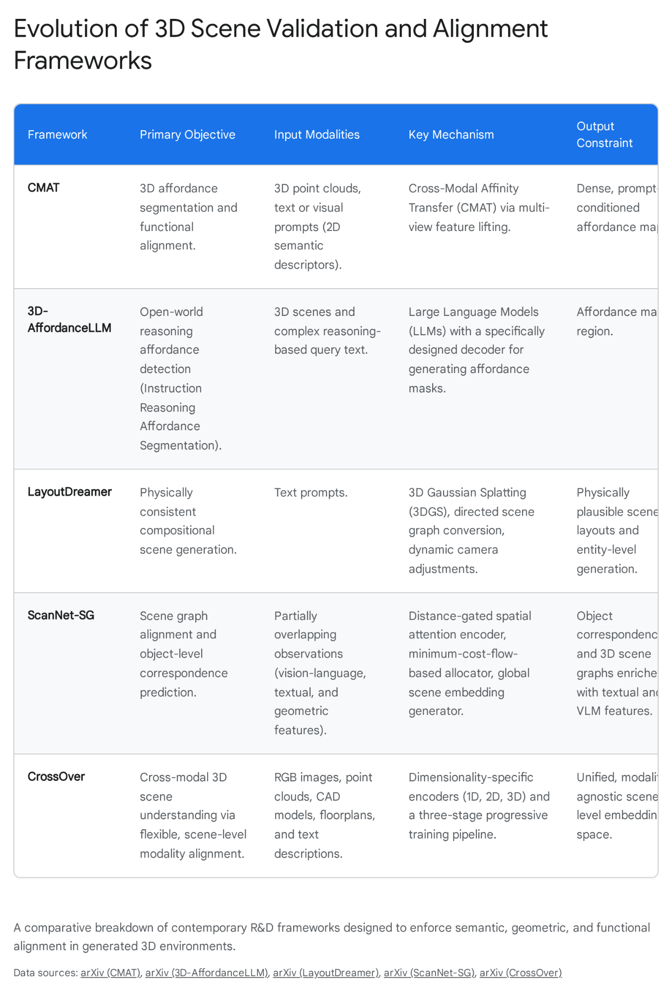

The robust spatial alignment of these scene graphs is absolutely paramount, particularly when establishing object correspondences across partially overlapping observations. This capability is a fundamental requirement for both multi-agent global map fusion and localized robotic relocalization when an agent revisits a previously generated or scanned place.¹¹ Frameworks evaluated on large-scale datasets like ScanNet-SG facilitate unified scene graph alignment through sophisticated modules, such as distance-gated spatial attention encoders and minimum-cost-flow-based allocators.¹¹ These tools enable precise frame-to-scan (F2S) alignment—matching partial RGB-D frames to a global scan—and subscan-to-subscan (S2S) alignment, fusing textual, geometric, and spatial context features to achieve accurate object correspondence even under severe viewpoint discrepancies or partial occlusions.¹¹
Furthermore, a significant limitation in multi-modal 3D object understanding is the assumption of strict object-level modality alignment.¹³ Traditional methods require datasets to possess perfectly corresponding, rigid modalities (e.g., RGB images, point clouds, CAD models, floorplans, and text descriptions) for every single object instance.¹³ In real-world or organically generated scenarios, such complete modality pairings are rarely available. Frameworks such as CrossOver mitigate this debilitating constraint by operating at the scene-level rather than the object-level, learning a highly unified, modality-agnostic embedding space.¹³ CrossOver's innovative three-stage training pipeline progressively builds relational capacity: it first captures object-level fine-grained connections, then develops unified scene representations without requiring perfectly aligned object pairs, and finally utilizes dimensionality-specific (1D, 2D, 3D) encoders to bypass the need for explicit 3D scene graphs or semantic labels during inference.¹³ This process yields powerful emergent cross-modal behavior, allowing an audit engine to accurately deduce that a generated image of a scene corresponds logically to a specific structural floorplan or textual description, even if that explicit pairing was entirely absent from the training data.¹³
In highly dynamic scenarios, spatial validation must extend into the temporal dimension. Frameworks like Drag4D introduce physics-aware object position learning and sophisticated 3D copy-and-paste methodologies, allowing users to define precise 3D trajectories for objects generated from text or single images.¹⁴ Drag4D enhances text-to-3D background generation using panoramic images and inpainted novel views, seamlessly embedding dynamic instance motion into high-quality generated backgrounds while explicitly preventing local motion hallucinations within the target instance.¹⁴ The integration of these temporal and spatial technologies into an audit pipeline allows for the preemptive detection of spatial drift, collision errors, and temporal hallucination before a generated environment is executed as a functional proxy.

Sim-to-Real Transfer and the Physics of Hallucination
The necessity for stringent, continuous auditing of language-to-world pipelines is perhaps most acute in the domain of autonomous robotics. Here, the "sim-to-real gap" acts as the unforgiving boundary between algorithmic success in a synthetic space and catastrophic physical failure in the real world. In the evolution of robotic learning, world models have traditionally functioned as relatively simple auxiliary predictors, utilized primarily to validate or rank candidate actions based on imagined future states.⁴ However, as the field has advanced rapidly with the rise of foundation models and large-scale video generation, the role of simulators has expanded drastically. They now serve as learned synthetic environments for deep reinforcement learning, post-training evaluation, and even dynamic co-evolution with operational policies, integrating directly into the core learning and decision-making infrastructures.⁴ Consequently, world models are no longer peripheral research novelties; they are the foundational proving grounds of robotic autonomy.
If a robotic agent is trained within a synthetic environment generated from an underspecified or poorly audited language prompt, any hallucinated physics, missing collision parameters, or false affordances within that environment will be directly and permanently encoded into the robot's physical behavioral policy. Academic institutions and research consortiums are heavily invested in mitigating these severe discrepancies. The Georgia Institute of Technology, through its Institute for Robotics & Intelligent Machines (IRIM), represents a primary hub for this research, housing interdisciplinary labs that approach autonomy from multiple angles.¹⁵ The Sonification Lab explores multimodal human-computer interfaces in complex task environments ¹⁵, while the Foundation Lab utilizes high-fidelity simulators to study team dynamics and psychological phenomena.¹⁵ The Hybrid Intelligence Lab models human-AI communication in safety-critical environments ¹⁵, and the Laboratory for Intelligent Decision and Autonomous Robots (LIDAR) develops formal methods guaranteeing robustness and safety for agile robots in adversarial environments.¹⁵
Specifically, the groundbreaking work emerging from Georgia Tech's Robot Autonomy and Interactive Learning (RAIL) lab, directed by Associate Professor Sonia Chernova, illustrates the critical need for robust affordance detection and explainable AI in robotic task planning.¹⁸ Chernova’s extensive research portfolio—spanning semantic reasoning, interactive learning from human demonstration, and active perception—underscores that a robot's ability to safely manipulate objects depends entirely on its capacity to accurately read environmental affordances.¹⁸ When dealing with inevitable robot failures, generating explainable AI outputs is vital; these systems must highlight precisely why an action failed based on a misinterpretation of state space, domain adaptation errors, or flawed human guidance.¹⁸ Her work on bi-directional domain adaptation for sim-to-real transfer specifically targets the vulnerabilities of embodied navigation agents when moving from synthetic training grounds to physical reality.²⁰ Furthermore, successes in integrated challenges, such as the ICRA FetchIt! Mobile Manipulation Challenge, demonstrate that theoretical affordance parsing must ultimately translate to high-stakes physical execution.¹⁸
Georgia Tech Research Vector | Lab / Principal Investigator | Relevance to Worldtext Auditing and Sim-to-Real Transfer
Robot Autonomy and Interactive Learning | RAIL Lab / Sonia Chernova | Focuses on semantic reasoning, interactive learning from demonstration, and explainable AI for robot failures, directly addressing how agents interpret synthetic vs. real affordances.
Intelligent Decision and Autonomous Robots | LIDAR Lab / Zhao Ye | Develops formal methods and computationally efficient optimization algorithms ensuring strict mathematical guarantees on robustness and safety for robots in unpredictable environments.
Hybrid Intelligence & Safety | Hybrid Intelligence Lab / Mengyao Li | Models and predicts human-AI communication and social cooperation in safety-critical environments, essential for human-in-the-loop oversight.
Computer Vision & 3D Reconstruction | BorgLab / Frank Dellaert | Solves large-scale problems in mapping, 3D reconstruction, and model-predictive control, providing the geometric ground truth required to validate generated scenes.
The Worldtext Audit Engine must serve as a critical, automated gatekeeper bridging this sim-to-real chasm. By executing continuous, automated audits on the synthetic training environments themselves, the engine ensures that cooperative perception networks and complex constraints are natively accounted for. For instance, initiatives like the DriveX 2026 workshop emphasize designing foundation models natively aware of real-world V2X (Vehicle-to-Everything) communications and multi-agent coordination.²¹ Constraint-based world modeling for mobile autonomous systems fundamentally requires that agents operate under the assumption of uncertainty and partial observability.²² By identifying when a description authorizes physically impossible actions, the audit engine drastically reduces the risk of catastrophic failure, ensuring that robots are not trained in deceptive, computationally hallucinated realities.

Normative and Legal Alignment in the Executable World
Beyond the physical constraints of geometry, collision, and affordance, generated worlds must be strictly bound by behavioral, societal, and legal parameters. The alignment of artificial intelligence systems encompasses both the normative problem of specifying precisely how systems should act in complex scenarios and the deeply technical challenge of ensuring that AI systems reliably comply with those specifications.²³ Historically, the main approaches to alignment in commercial systems have focused primarily on steering systems to follow the direct instructions of users, advancing the corporate interests of developers, and implementing basic guardrails against generating toxic or harmful content.²⁴ However, as AI systems and autonomous agents are deployed more widely across the economy, engaging in increasingly complex tasks from autonomous coding to financial trading, the risk profiles shift dramatically. The prospect of multi-agent and systemic failures increases exponentially; algorithmic systems may inadvertently collude to fix prices, compete destructively to bring down entire markets, or engage in unforeseen adversarial behaviors without immediate human intervention.²³
Addressing these macro-level systemic risks requires moving beyond baseline human-preference alignment and crowdsourced ethical pluralism. Extensive research by Mark Riedl, a prominent human-centered AI expert at Georgia Tech, and his colleagues advocates strongly for the emerging field of "legal alignment".²³ Legal alignment focuses on designing AI systems to explicitly comply with the content of established legal rules developed through legitimate democratic institutions and processes.²³ It adapts robust methods from legal interpretation to guide how AI systems reason, make decisions, and exercise discretion, particularly in novel scenarios and high-stakes settings.²³ Legal alignment functions as a critical, non-negotiable lower bound for safety, explicitly ensuring that AI systems do not execute actions constituting civil wrongs (e.g., negligence) or criminal offenses (e.g., insider trading, computer hacking).²³ This framework mitigates the risk of systemic collapse by utilizing existing legal infrastructures to throttle the speed and scale at which autonomous agents operate, establishing conflict-of-law principles to determine appropriate jurisdictional boundaries in synthetic or cross-border computational interactions.²³
While legal alignment provides a rigid floor, normative alignment remains necessary to constrain agent behavior according to expected societal and cultural contracts.²⁶ However, Riedl's research highlights a profound technical hurdle: how does a system learn nebulous "values," from what data, and how does it formally constrain its behavior based on those learned norms?.²⁶ Effective alignment relies heavily on the advancement of explainable reinforcement learning (RL). End-users typically form mental models of an AI agent's decision-making process that fail to adequately capture the mathematical realities of RL policies—where policies seek higher values resulting in larger future expected rewards without inherently capturing the why of a decision.²⁶
To bridge this understanding gap, AI systems must utilize "experiential explanations." This involves learning to map the influences that certain environmental states have on the utilities of other states, and then presenting these influences as clear counterfactual explanations for why a particular trajectory was not preferred by the agent's policy.²⁶ For example, instead of a black-box refusal, an agent navigating a generated space would explain, “I did not proceed down the path because the geometric rendering indicated I might fall down the stairs”.²⁶ This provides immediate actionability, allowing the end-user to update their mental model or alter the generated environment to achieve expected behavior safely.²⁶ The Worldtext Audit Engine incorporates these complex legal and normative alignment parameters, actively flagging language prompts that attempt to generate environments devoid of requisite legal guardrails or that force agents into legally compromised operational states.

The HCI Challenge: Audit Friction and Compliance Theater
The architectural and theoretical formulation of the Worldtext Audit Engine is ultimately futile if the resulting toolset is incompatible with the practical realities of industry workflows. The brief history of algorithmic auditing is already marked by a persistent, frustrating gap between the aspirational accountability goals of researchers and the practical, day-to-day realities faced by practitioners attempting to deploy Responsible AI (RAI) in corporate settings.²⁷ Extensive human-computer interaction (HCI) research by Wesley Hanwen Deng at Carnegie Mellon University critically examines these sociotechnical challenges, highlighting that while numerous tools, principles, and frameworks exist for impact assessment and red-teaming, they frequently encounter severe adoption friction.²⁷
The adoption of audits within the AI space—encompassing risk assessments, classification models, and generative text-to-3D systems—draws inspiration from diverse fields including social science, clinical trials, and finance.²⁸ Audits are currently conducted by a fractured ecosystem of regulators, law firms, civil society organizations, academics, and specialized consulting agencies (e.g., BNH.AI, AWO, Foxglove).²⁸ However, these audits often fail to translate into concrete, desired accountability outcomes.²⁸ Unlike more mature audit industries, AI audits do not consistently incite product recalls, force the disclosure of secret contracts, inform fundamental product re-designs, or successfully shape broader internal corporate policies.²⁸ To combat this systemic ineffectiveness, tools must be seamlessly integrated into existing sensemaking workflows rather than layered on as bureaucratic afterthoughts. Deng's development of platforms like WeAudit—a generalizable workflow scaffolding end users in investigating and reporting generative AI harms—and the PersonaTeaming Playground—which incorporates user personas into automated red-teaming algorithms—demonstrate the necessity of designing tools that foster genuine, low-friction human-AI collaboration during evaluation.²⁷
However, even successfully integrated tools risk rapidly degrading into "compliance theater" if human oversight is procedurally mandated by law but functionally impotent in practice. The regulatory landscape is tightening; frameworks including the European AI Act, the Federal Reserve and OCC's SR 11-7 model risk guidance for financial services, and HIPAA for healthcare data mandate stringent human-in-the-loop (HITL) monitoring, data protection impact assessments, and compliance testing for high-risk AI deployments.²⁹ Yet, the legal definition of meaningful oversight is highly precise. Genuine oversight requires a demonstrable, unshakeable delegation chain—a tamper-evident audit record proving unequivocally that every single AI agent action is attributable to a specific human authorizer.³⁰

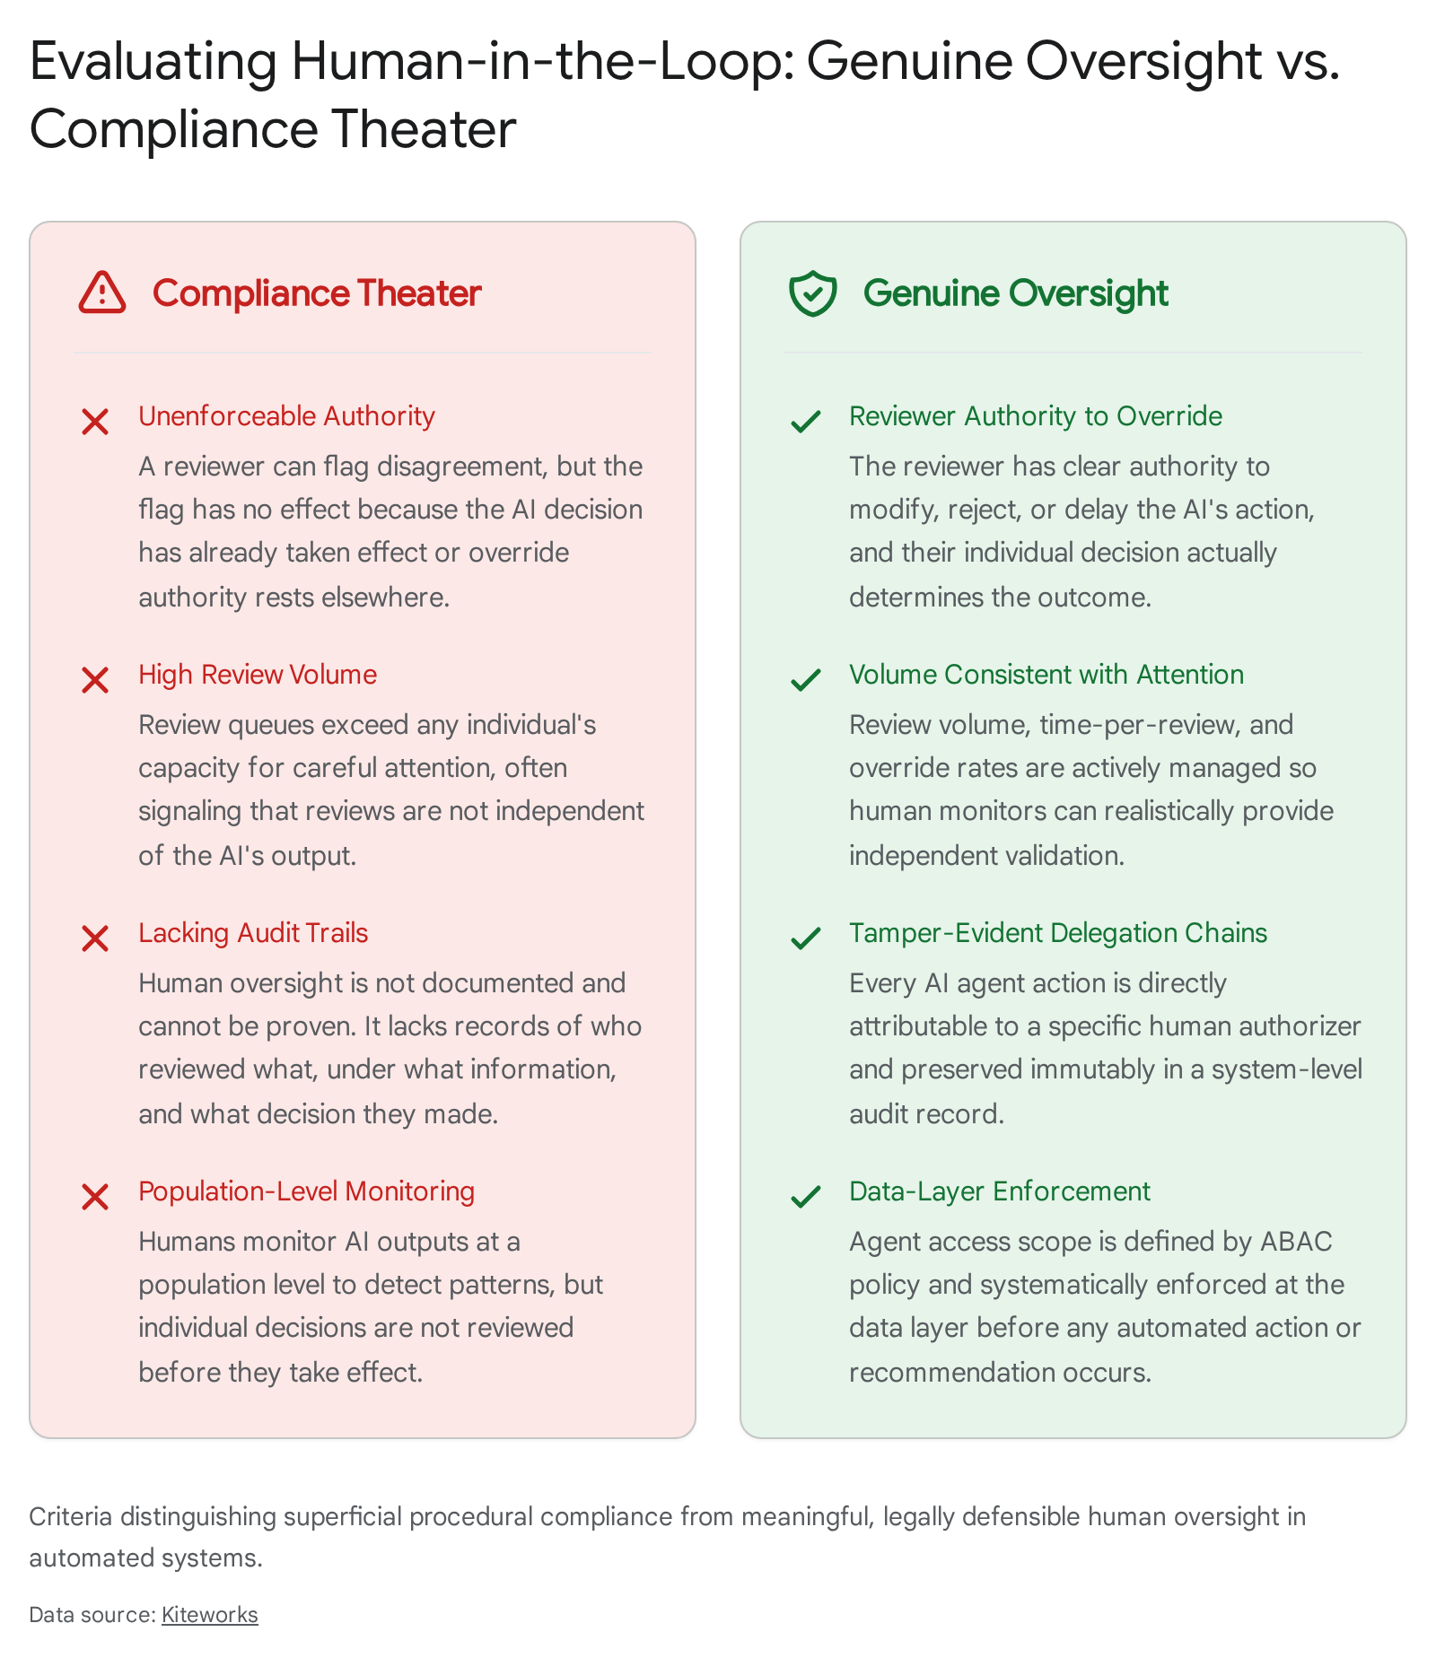

If a human reviewer is placed in the loop but can only flag a disagreement—and that flag has no actual effect because the AI decision has already been executed, or because the reviewer structurally lacks override authority—the oversight is legally and functionally invalid.³⁰ Furthermore, review volumes must remain consistent with genuine, focused human attention. Review queues that vastly exceed individual cognitive capacity, resulting in near-zero override rates, act as a massive red flag to regulators, signaling that human reviews are dangerously independent of the AI's actual output.³⁰ Compliance managers must update protocols by implementing rigorous AI governance frameworks that include continuous audits, risk assessments, and, crucially, data-layer enforcement.³⁰ The Worldtext Audit Engine must natively produce these required artifacts without adding workflow friction. It must automatically log every parameter of the text-to-world transformation, ensuring that when an AI system invokes a physical rule or initiates an action based on an original language prompt, the exact chain of computational interpretation is preserved in a tamper-evident audit trail feeding organizational SIEM (Security Information and Event Management) systems.³⁰ This necessary transition ensures that standard-setting becomes an enforceable institution of global governance, building verifiable trust among developers through transparent, fail-safe design specifications.³³

Deployment Vectors, Wedge Products, and Scalability
The ultimate success and scalability of the Worldtext Audit Engine rely entirely on its strategic, phased integration into diverse domains where language currently operationalizes space and action. The deployment strategy follows a progressive pathway, moving from foundational research and development prototypes into highly regulated, high-stakes enterprise applications via specific wedge products.
- Spatial Computing and XR Design Validation: XR designers frequently rely on generative interfaces to rapidly prototype spatial scenes and immersive layouts. In this domain, the audit engine functions as a lightweight, unobtrusive interface plugin within dominant platforms like Unity or Unreal Engine. It runs silently in the background, instantly compiling textual prompts into inspectable scene graphs. It automatically identifies instances where generated aesthetic surfaces (e.g., a visually complex, beautifully rendered spiral staircase) completely lack the underlying collision meshes or NavMesh parameters required for user traversal. By rigorously separating cinematic plausibility from operational reliability, it prevents the deployment of XR environments harboring false affordances that break immersion or cause interaction failures.
- Robotics Simulation Risk Gating: In the field of robotics, where the sim-to-real gap is the primary barrier to safe commercial deployment, the audit engine acts as an uncompromising authorization gate. Before an autonomous agent (such as a quadrupedal robot navigating unstructured terrain or a robotic arm engaged in mobile manipulation) is trained on a newly generated synthetic dataset, the engine cross-references the environment's affordance maps against known, absolute physical constraints.¹⁷ If a prompt-generated environment hallucinate material properties—for example, assigning the high friction coefficient of dry asphalt to a surface visually rendered and prompted as wet ice—the engine immediately flags the anomaly, actively preventing the agent from internalizing fatal operational behaviors that would result in hardware destruction upon physical deployment.²⁰
- Museum and Institutional Interpretation Debugging: Museums, galleries, and cultural heritage sites are increasingly turning static descriptions into mediated action-spaces via spatial computing, digital twins, and immersive installations. Wall labels, curatorial documentation, and historical texts are being operationalized into interactive simulation contracts. Here, the audit engine serves as a specialized interpretation mapper. It ensures that the generated spatial experiences remain faithfully and strictly bound to the verified curatorial intent, automatically detecting interpretive overreach, historical hallucinations, or the degradation of historical fact into mere unmoored sensory spectacle.
- Agent Affordance Monitoring and Legal Compliance: For enterprise digital twin operators, financial compliance officers, and AI governance teams, the engine provides an overarching, tamper-evident audit dashboard. It continuously monitors the affordances presented to LLM-driven agents executing tasks within simulated or live enterprise environments. Utilizing frameworks derived directly from legal alignment research, the engine ensures that the actions authorized by the generated environment do not violate predefined legal boundaries, such as antitrust laws or data privacy regulations.²³ This rigorous monitoring guarantees that multi-agent interactions remain within safe, compliant operational parameters, fulfilling the strict regulatory obligations mandated by emerging legislation such as the European AI Act and specific sector guidelines.²⁹

Conclusion
The transition of artificial intelligence from text-to-image synthesis to comprehensive text-to-world generation represents a profound and hazardous leap in computational complexity. Description is no longer an interpretive endpoint; it has become an active, highly volatile production mechanism capable of instantiating physics, defining realities, and guiding autonomous action. As such, the evaluation paradigms for generative AI must shift unequivocally and permanently from the subjective appreciation of aesthetic output to the strict, verifiable accountability of world-building constraints.
The Worldtext Audit Engine provides the necessary translational R&D framework to achieve this vital shift. By seamlessly synthesizing deep theoretical insights from speech act theory and procedural rhetoric with cutting-edge technical methodologies—including cross-modal affordance segmentation, scene graph alignment, sim-to-real robotics validation, and rigorous compliance tracking—the engine systematically dismantles the dangerous illusion of visual plausibility. It ensures that the environments we summon through language are not merely convincing to the human eye, but are structurally sound, physically possible, and legally valid. In doing so, it transforms the inherently unpredictable and hallucinatory nature of generative models into safe, inspectable, and profoundly accountable architectures for real-world action.

Works cited
- Unlocking 3D Affordance Segmentation with 2D Semantic Knowledge - arXiv, accessed June 4, 2026, https://arxiv.org/html/2510.08316v2
- GPT-4V(ision) is a Human-Aligned Evaluator for Text-to-3D Generation - arXiv, accessed June 4, 2026, https://arxiv.org/html/2401.04092v2
- LayoutDreamer: Physics-guided Layout for Text-to-3D Compositional Scene Generation, accessed June 4, 2026, https://arxiv.org/html/2502.01949v1
- World Model for Robot Learning: A Comprehensive Survey - arXiv, accessed June 4, 2026, https://arxiv.org/html/2605.00080v1
- Taxonomizing Representational Harms using Speech Act Theory - arXiv, accessed June 4, 2026, https://arxiv.org/html/2504.00928v2
- Evaluating Large language models on Understanding Korean indirect Speech acts - arXiv, accessed June 4, 2026, https://arxiv.org/html/2502.10995v1
- Taxonomizing Representational Harms using Speech Act Theory - arXiv, accessed June 4, 2026, https://arxiv.org/html/2504.00928v1
- Composition + Videogames - Procedural Rhetoric - Google Drive: Sign-in, accessed June 4, 2026, https://sites.google.com/site/composingvideogames/six-levels-of/level-4-critical-game-studies/procedural-rhetoric
- End-to-end Listen, Look, Speak and Act - arXiv, accessed June 4, 2026, https://arxiv.org/html/2510.16756v1
- 3D-AffordanceLLM: Harnessing Large Language Models for Open-Vocabulary Affordance Detection in 3D Worlds - arXiv, accessed June 4, 2026, https://arxiv.org/html/2502.20041v1
- OpenSGA: Efficient 3D Scene Graph Alignment in the Open World - arXiv, accessed June 4, 2026, https://arxiv.org/html/2605.10484v1
- ReSpace: Text-Driven 3D Scene Synthesis and Editing with Preference Alignment - arXiv, accessed June 4, 2026, https://arxiv.org/html/2506.02459v1
- CrossOver: 3D Scene Cross-Modal Alignment - arXiv, accessed June 4, 2026, https://arxiv.org/html/2502.15011v1
- Drag4D: Align Your Motion with Text-Driven 3D Scene Generation - arXiv, accessed June 4, 2026, https://arxiv.org/html/2509.21888v1
- Labs - Center for Human-AI-Robot Teaming, accessed June 4, 2026, https://chart.gatech.edu/labs/
- Robotics | School of Interactive Computing - Georgia Tech, accessed June 4, 2026, https://www.ic.gatech.edu/robotics
- Institute for Robotics and Intelligent Machines (IRIM) - Georgia Tech Research, accessed June 4, 2026, https://research.gatech.edu/robotics
- Sonia Chernova - Georgia Tech, accessed June 4, 2026, https://faculty.cc.gatech.edu/~chernova/
- Sonia Chernova - School of Interactive Computing - Georgia Tech, accessed June 4, 2026, https://www.ic.gatech.edu/people/sonia-chernova
- Sonia Chernova - Google Scholar, accessed June 4, 2026, https://scholar.google.pl/citations?user=EYo_WkEAAAAJ&hl=es
- DriveX 2026 – Foundation Models for Autonomous Driving, accessed June 4, 2026, https://drivex-workshop.github.io/cvpr2026/
- Constraint Based World Modeling for Multi Agent Systems in Dynamic Environments, accessed June 4, 2026, https://www.researchgate.net/publication/225460155_Constraint_Based_World_Modeling_for_Multi_Agent_Systems_in_Dynamic_Environments
- Legal Alignment for Safe and Ethical AI - arXiv, accessed June 4, 2026, https://arxiv.org/html/2601.04175v1
- Legal Alignment for Safe and Ethical AI - arXiv, accessed June 4, 2026, https://arxiv.org/pdf/2601.04175
- Mark Riedl, human-centered artificial intelligence expert - Georgia Tech, accessed June 4, 2026, https://www.gatech.edu/expert/mark-riedl-human-centered-artificial-intelligence-expert
- Mark Riedl Georgia Institute of Technology riedl@cc.gatech.edu @mark_riedl, accessed June 4, 2026, https://cra.org/ccc/wp-content/uploads/sites/2/2022/04/Mark_Riedl_AI-OR_Slides.pdf
- Supporting Safe and Responsible AI in Industry Practice, accessed June 4, 2026, http://reports-archive.adm.cs.cmu.edu/anon/hcii/CMU-HCII-26-102.pdf
- AI auditing: The Broken Bus on the Road to AI Accountability - arXiv, accessed June 4, 2026, https://arxiv.org/html/2401.14462v1
- How to Test for Compliance with Human Oversight Requirements in AI Regulation? - arXiv, accessed June 4, 2026, https://arxiv.org/html/2504.03300v1
- Human in the Loop: AI Compliance and Oversight Requirements - Kiteworks, accessed June 4, 2026, https://www.kiteworks.com/regulatory-compliance/human-in-the-loop-ai-compliance/
- Meeting AI Compliance Requirements: The Definitive Guide - Mirantis, accessed June 4, 2026, https://www.mirantis.com/blog/ai-compliance-requirements-the-definitive-guide/
- Compliance in the Age of AI: Addressing the Dangers of Artificial Intelligence - Parakeet Risk, accessed June 4, 2026, https://parakeetrisk.com/blog/compliance-in-the-age-of-ai-addressing-the-dangers-of-artificial-intelligence
- Standards for AI Governance: International Standards to Enable Global Coordination in AI Research & Development, accessed June 4, 2026, https://cdn.governance.ai/Standards_-FHI-Technical-Report.pdf

